Africa Map
Number Label each state and its capital.
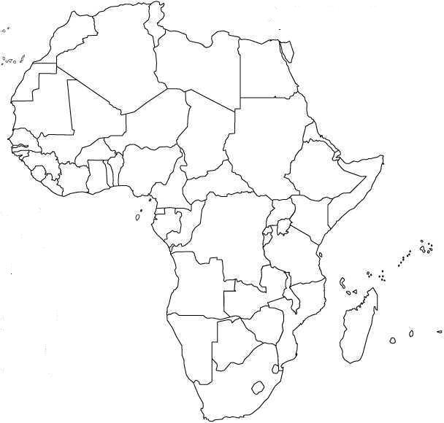

Identify the physical landform identified by the following symbol.

